四年級英語繪本書目
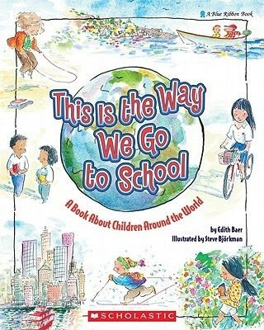 | 1.This is the way we go to school  【圖書館既有班級共讀30本藏書】  https://www.youtube.com/watch?v=1eBZAh1lN2E
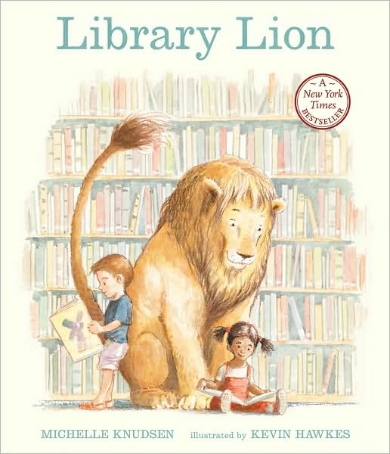 | 2.Library Lion - Michlle Knudsen  【圖書館有中文版藏書】  https://www.youtube.com/watch?v=T18NCobS43c
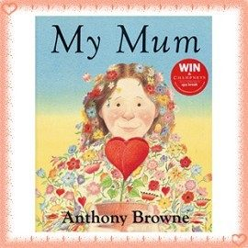 | 3. My mom - Anthony Browne  https://www.youtube.com/watch?v=mtwYBfN8YNM
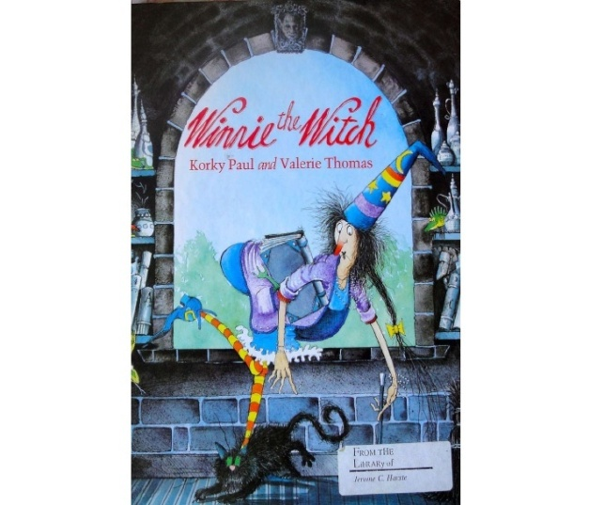 | 4.Winnie the Witch - Valerie Thomas  https://www.youtube.com/watch?v=3jO5Omszt74

